**Database Management System – cs422 DE**

**Lab 1 – Wk 3 & 4**

-----------------------------------------------------------------------------------------------------------------

**This Lab is based on lecture 3 & 4 (chapters 6 & 7).**

* Submit your *own work* on time. No credit will be given if the lab is submitted after the due date.
* Note that the completed lab should be submitted in .zip or .rar format only.
* If you think that your answer needs explanation to get credit then please write it down.   
  ---------------------------------------------------------------------------------------------------------------

Solve the questions from 6.32 to 6.40 in the Case Study 2 on page no. 173 (5th edition).

You are required to run & test all these queries in SQL Server. Note that you’ll need to create and populate the tables first.

To get full credit for this lab, you need to submit the following:

1. Screenshots for at least 4 of the queries with output.
2. Answer SQL queries for all of the mentioned exercises.

For your quick reference, the schema and the questions are given below.

Employee (**empID**, fName, lName, address, DOB, sex, position, deptNo)

Department (**deptNo**, deptName, mgrEmpID)

Project (**projNo**, projName, deptNo)

WorksOn (**empID**, **projNo**, hoursWorked)

where

* *Employee* contains employee details and *empID*is the key.
* *Department* contains department details and *deptNo*is the key. *mgrEmpID* identifies the employee who is the manager of the department. There is only one manager for each department.
* *Project* contains details of the projects in each department and the key is *projNo*(no two departments can run the same project).
* *WorksOn* contains details of the hours worked by employees on each project, and *empID/projNo*form the key.

**Exercises**

1. List all employees in alphabetical order of surname and within surname, first name.

ANS:

**SELECT * FROM employee ORDER BY lName, fname;**

1. List all the details of employees who are female.  
   ANS:

**SELECT * FROM employee WHERE sex = 'Female';**

1. List the names and addresses of all employees who are Managers.

ANS:

**SELECT fname, lName, address FROM employee WHERE empID IN (SELECT mgrEmpID FROM department);**

1. Produce a list of the names and addresses of all employees who work for the IT department.

ANS:

**SELECT fname, lName, address FROM employee WHERE deptNo = (SELECT deptNo FROM department WHERE deptName = 'IT Department');**

1. Produce a complete list of all managers who are due to retire this year, in alphabetical order of surname.

ANS:

**SELECT fname, lName, address**

**FROM employee**

**WHERE empID IN (SELECT mgrEmpID FROM department)**

**AND YEAR(DOB) <= (2023 - 65)**

**ORDER BY lName;**

1. Find out how many employees are managed by ‘James Adams’.

ANS:

**SELECT COUNT(*) AS numEmployees**

**FROM employee**

**WHERE mgrEmpID = (SELECT empID FROM employee WHERE fname = 'James' AND lName = 'Adams');**

1. Produce a report of the total hours worked by each employee, arranged in order of department number and within department, alphabetically by employee surname.

ANS:

**SELECT e.empID, e.fname, e.lName, e.deptNo, SUM(w.hoursWorked) AS totalHours**

**FROM employee e**

**JOIN WorksOn w ON e.empID = w.empID**

**GROUP BY e.empID, e.fname, e.lName, e.deptNo**

**ORDER BY e.deptNo, e.lName;**

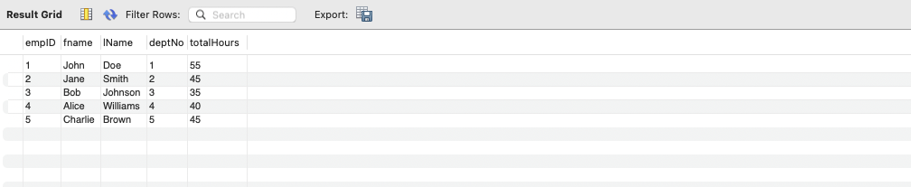

1. For each project on which more than two employees worked, list the project number, project name and the number of employees who work on that project.

ANS:

**SELECT p.projNo, p.projName, COUNT(w.empID) AS numEmployees**

**FROM Project p**

**JOIN WorksOn w ON p.projNo = w.projNo**

**GROUP BY p.projNo, p.projName**

**HAVING COUNT(w.empID) > 2;**

1. List the total number of employees in each department for those departments with more than 10 employees. Create an appropriate heading for the columns of the results table.

ANS:

**SELECT d.deptNo, d.deptName, COUNT(e.empID) AS numEmployees**

**FROM department d**

**JOIN employee e ON d.deptNo = e.deptNo**

**GROUP BY d.deptNo, d.deptName**

**HAVING COUNT(e.empID) > 10;**

